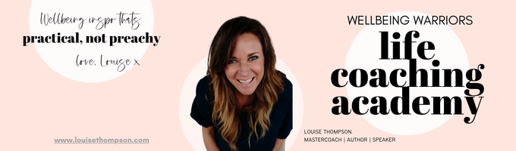
~ Neutralising Niggles ~ Worksheet 1 - May 2024

Watch the tutorial, first then complete this worksheet!

CREATE YOUR OWN NIGGLE LIST OF OPEN LOOPS!

Brain dump here a few of the things you have just been “putting up with” or “putting off”…no task/conversation/action/decision is too small to list. They are all sucking up energy in the background. Get them down on paper!

Renewing your passport? Taking that pile of books to charity? Replacing that dodgy remote that never works properly and drives you mad every single evening?

Perfect. List those Niggles. Get them out of your brain and onto paper where you can start to ANALYSE them! Then move on to the second section where you can dive deeper into what’s been blocking you taking action to date. This is about uncovering your PATTERNS.

PS: There is an extended worksheet to list up to 100 also included in this module (where you can divide into DELETE, DELEGATE, DIARY, OR DEAL) this sheet is just taking a few and analysing for personal insight ☺

- ____________________________________________________________________________
- ____________________________________________________________________________
- ____________________________________________________________________________
- ____________________________________________________________________________
- ____________________________________________________________________________
- ____________________________________________________________________________
- ____________________________________________________________________________
- ____________________________________________________________________________
- ____________________________________________________________________________
- ____________________________________________________________________________
- ____________________________________________________________________________
- ____________________________________________________________________________

Dive a little bit deeper….pick 5 of the above and see what patterns and triggers you can find for yourself:

HOUSEHOLD task/conversation/action/decision I have been putting off

For approx. how long
Why have I been avoiding it?
What uncomfortable emotion have I been trying not to feel?
How long do I think this thing would take, really?
Can I withstand the uncomfortable emotion you have identified for the duration of the minutes it will take you to complete the action? YES / NO?
How will I feel when it’s done?

HEALTH task/conversation/action/decision I have been putting off:

For approx. how long
Why have I been avoiding it?
What uncomfortable emotion have I been trying not to feel?
How long do I think this thing would take, really?
How will I feel when it’s done?

RELATIONSHIP task/conversation/action/decision I have been putting off:

For approx. how long
Why have I been avoiding it?
What uncomfortable emotion have I been trying not to feel?
How long do I think this thing would take, really?
Can I withstand the uncomfortable emotion you have identified for the duration of the minutes it will take you to complete the action? YES / NO?
How will I feel when it’s done?

CAREER task/conversation/action/decision I have been putting off:

For approx. how long
Why have I been avoiding it?
What uncomfortable emotion have I been trying not to feel?
How long do I think this thing would take, really?
Can I withstand the uncomfortable emotion you have identified for the duration of the minutes it will take you to complete the action? YES / NO?

How will I feel when it’s done?

SOCIAL task/conversation/action/decision I have been putting off

For approx. how long
Why have I been avoiding it?
What uncomfortable emotion have I been trying not to feel?
How long do I think this thing would take, really?
Can I withstand the uncomfortable emotion you have identified for the duration of the minutes it will take you to complete the action? YES / NO?

How will I feel when it’s done?

Fill in any more that come to mind:

____________ task/conversation/action/decision I have been putting off:

For approx. how long
Why have I been avoiding it?
What uncomfortable emotion have I been trying not to feel?
How long do I think this thing would take, really?
Can I withstand the uncomfortable emotion you have identified for the duration of the minutes it will take you to complete the action? YES / NO?

How will I feel when it’s done?

____________ task/conversation/action/decision I have been putting off:

For approx. how long
Why have I been avoiding it?
What uncomfortable emotion have I been trying not to feel?
How long do I think this thing would take, really?
Can I withstand the uncomfortable emotion you have identified for the duration of the minutes it will take you to complete the action? YES / NO?

How will I feel when it’s done?

____________ task/conversation/action/decision I have been putting off:

For approx. how long
Why have I been avoiding it?
What uncomfortable emotion have I been trying not to feel?
How long do I think this thing would take, really?
Can I withstand the uncomfortable emotion you have identified for the duration of the minutes it will take you to complete the action? YES / NO?

How will I feel when it’s done?

Nice work, and I am sure a few “Interesting Mister Bond moments, no? What are the themes of patterns you have noticed?

Use this list as a powerful prompt for your work on the challenges this month.

