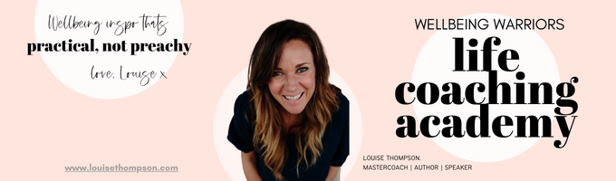
~ 100 Day Dash ~ Worksheet - September 2023

Hey lady! It’s time to do some self-awareness work as a foundation for your 100 Day Dash to bring the year home strong!

*Please remember, WW is a judgement-free zone (esp. with ourselves!) so PLEASE just be OBJECTIVE with your answers rather than judgemental about it. Take the learning and the aha moments and drop the opportunity to beat yourself up! We are winning or learning, remember 😊 So…let’s learn!

What have you ALREADY accomplished in 2023 that you planned as a goal? Where have you WON? Why?

What did you want to accomplish in 2023 that you haven’t yet?

Have you started? Where are you at? Are you on track to complete by the end of the year with 100 days to go?

If you are not on track to accomplish it, why not?* Why hasn’t it happened yet? Or why is it not on track?

Do you still want to accomplish this goal in 2023?

Why?

What are the consequences if you DO accomplish it?

What are the consequences if you DON’T accomplish it?

Do you want to refine or change this goal?

Is there anything you are absolutely SICK of not accomplishing that you want to get done once and for all in 2023, and not drag undone into 2024?

DECLARATION:

You have 100 usable days left in 2023 to really FOCUS. You can achieve truly SIGNIFICANT things in 100 Days with a laser focus.

What do you choose to commit to getting accomplished in the 100 Day Dash to finish 2023 strong? Define it here:

In the next 100 days I will…..

Good job! Make sure you head straight on over to the challenges and start locking in your 100 days of focused intention in the 100 Day Dash!

